TASK 1: IMAGE GENERATION ON HUGGING FACE

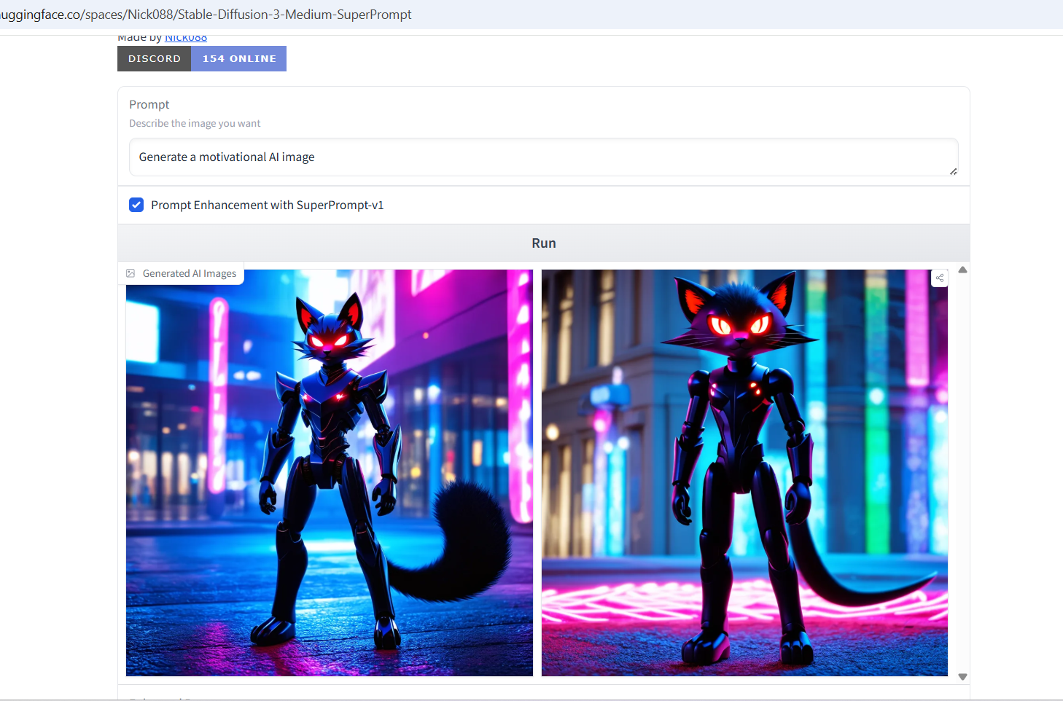

TASK TWO: GETTING OF DATASET USING KAGGLE
https://www.kaggle.com/datasets/yasserh/housing-prices-dataset

One sentence:
Having a large amount of housing price data allows an AI model to learn patterns between property features and prices, improving its ability to make accurate predictions.

TASK THREE: GOOGLE COLLAB ASSIGNMENT

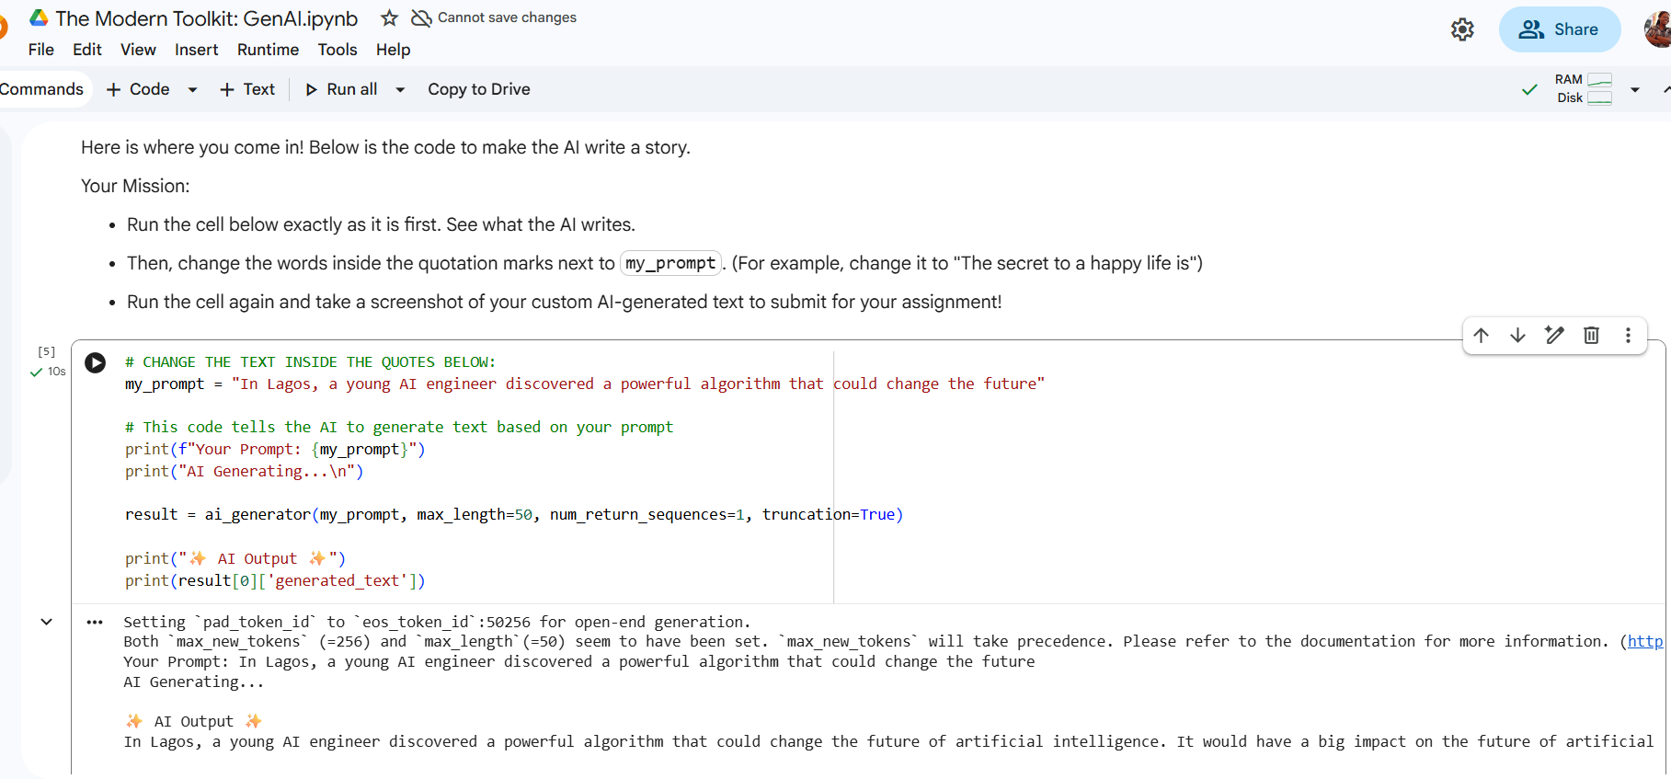

TASK FOUR: GITHUB ACCOUNT CREATION

